Help or Harm
Instructions: For the following three varieties of selective or differential media, choose the bacteria from the bank that most likely is represented on the photograph. Write the appropriate answer below. Secondly, identify three characteristics of the media that inhibits, promotes, or differentiates the growth of specific microorganisms. Also identify whether the media is selective, differential, or both. You may use your notes or the internet sites provided on the Web Quest to complete the assignment. When finished, save the file as Lastname_Firstname and EMAIL to entermailhere@schooldistrict.com DO NOT PRINT.
MacConkey Agar:
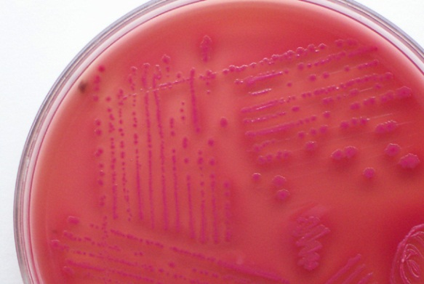
Bank: (Escherichia coli, Salmonella typhimurium, Staphylococcus aureus, Enterococcus faecalis)
Possible microorganism(s):____________________ ___________________
Circle: Selective Differential Selective & Differential
Defining media characteristics:

Mannitol Salt Agar (MSA):
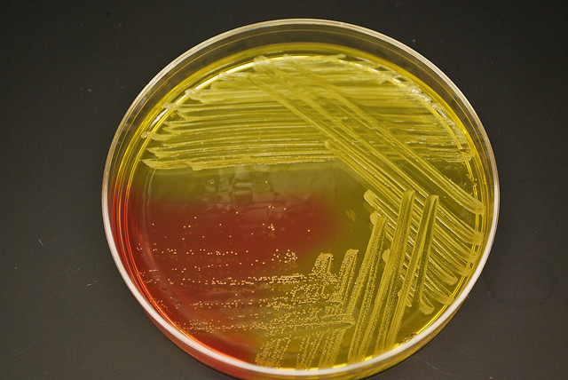

Bank: (Escherichia coli, Staphylococcus aureus, Staphylococcus epidermidis, Serratia marcescens)
Possible microorganism(s):____________________ ___________________
Circle: Selective Differential Selective & Differential
Defining media characteristics:

Eosin Methylene Blue (EMB) Agar:
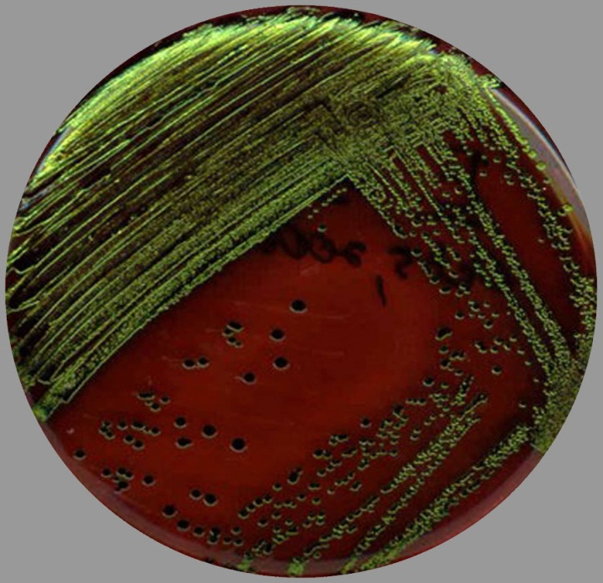
Bank: (Escherichia coli, Enterococcus faecalis, Psuedomonas aeruginosa,, Serratia marcescens)
Possible microorganism(s):____________________ ___________________
Circle: Selective Differential Selective & Differential
Defining media characteristics:

